**PE-PRJ-TP-TCP-XXXXX**

**May 10, 2023**

**MOV/Jib crane repair work**

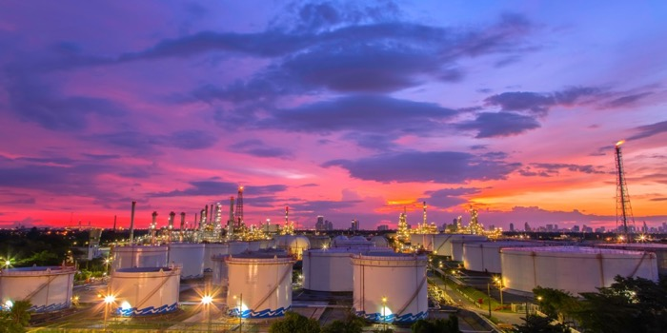

1. **Introduction**

SK Ecoplant, represented by the Procurement Division, intends to do flaking repair works for the three Jib Cranes and two Motor Operated Valves at M Project, Fujairah, United Arab Emirates.

Our technical team evaluated furnished documents and provided the below offer.

1. **Scope of Work**

The Project calls for re-blasting and re-painting three jib cranes (One at west area and two at East area) and flaking repair for two Motor Operated Valves in the west area using LC1-N paint system or as per client requirements.

**Inclusions**:

* Supply of qualified manpower,
* Hand & Power Tools and any other tools required to perform job,
* Airless spray ad blasting machines
* Supervision Team,
* General Housekeeping shall be done after work completion,
* Daily reports and detailed reports after completion of job,
* Cost of all gate passes and medical tests required for site entry

**Exclusions**:

* Materials Supplying (Paint)
* Inspection and Test Plan (ITP), Risk analysis and method of statement of the job,
* Submit the Site WPS,
* AQT & PQT,
* Scaffolding / Rigging, all rigging tools,
* Electricity- 3 Phase /other Yard Facilities (Air and/or water),
* Resting place for our Crew,
* Any works other than mentioned.

1. **Duration**

Duration required for this project is 20 Working days, after permit to work approval by SK and painters’ qualification on site (if required by SK or ADNOC).

1. **Technical Approach**

Our approach to this Project is to finalize blasting and painting for each item in series and the task will be divided into four phases. The approach, to be used for each phase, will now be presented in some detail hereinafter.

**Work Execution**

* 1. **Blasting and removal of old paint system (Phase I)**
* Covering all surroundings in order for the blasting process to not affect any unrequired member.
* Blasting Application of very thorough blast cleaning (sa 2.5 as per ISO8501) to reach 35-65 microns of surface profile
  1. **Application of Primer (Phase II)**
* Application of first coat (Primer) using airless spray (Inorganic zinc silicate/zinc rich primer as per Shell D.E.P 30.48.00.31-Gen. or as per client requirements.
  1. **Application of Topcoat (Phase II)**
* Application of Topcoat (polyurethane topcoat as per Shell D.E.P 30.48.00.31-Gen. or as per client requirements).
  1. **Inspection and Quality Handover (Phase IV)**
* PE Team to raise RFI to SK team to hand over work.

1. **Work Force Deployment**

As per MSRA.

1. **Price**

Cost of above-mentioned works is as per attached priced Table of Quantities.

1. **Payment Terms**

TBD

1. **Force Majeure**

Our offer is governed by Standard force majeure clause prevailing in UAE.

We hope we are in line with your requirements

1. **Validity of offer**

Our offer is kept valid for a period of 30 Days from the date for submission.

1. **Attachments**
2. **Addendum I**: Priced Table of Quantities.**Addendum I (Prices)**

|  |  |  |  |  |  |
| --- | --- | --- | --- | --- | --- |
| **Sr.** | **Work description** | ***Unit*** | ***QTY*** | ***Unit Price*** | ***Amount*** |
| **1** | **Mobilization & Demobilization** | LS | 1 |  | USD |
| **2** | **Blasting and painting for Jib Cranes** | *M2* | *Arround 250 m2* |  | *USD* |
| **3** | **Blasting and painting for MOV** | EA | 2 |  | *USD* |
|  |  |  |  | **USD** | |